VPC Peering:

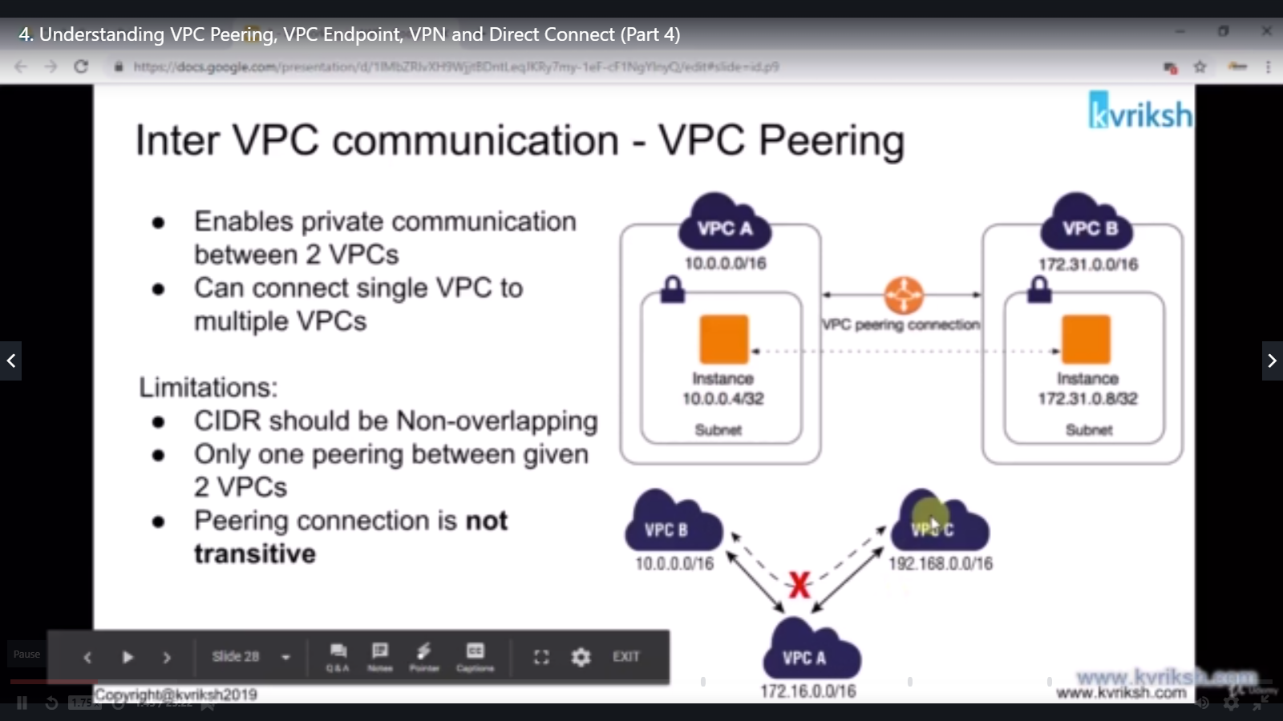

VPC peering concept is to establish connection between two vpc’s

Consider the below diagram

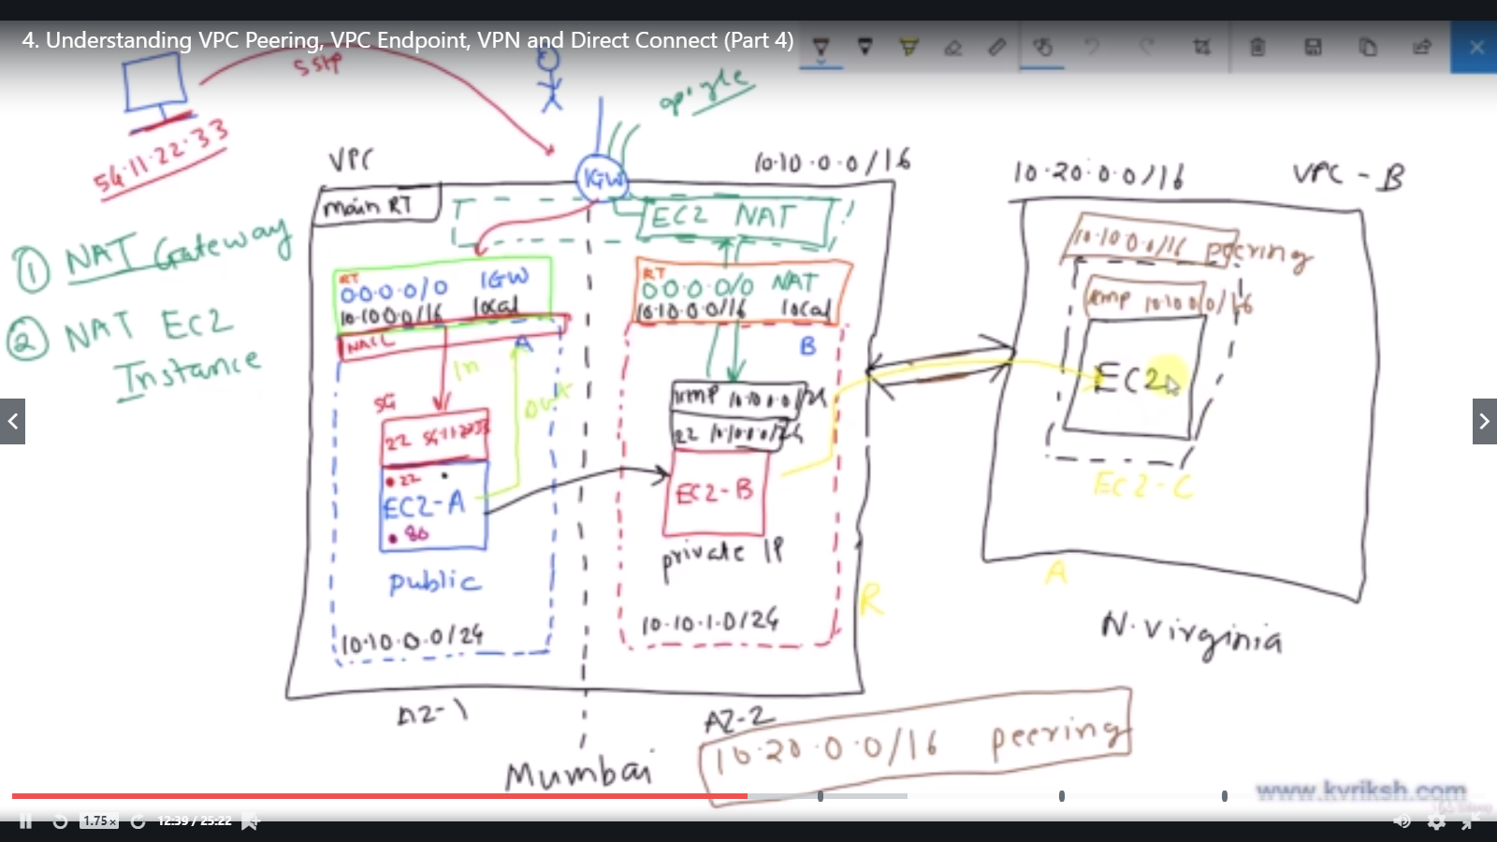

Please refer to previous notes to understand this.

Left side we have a vpc with two subnets (one private , one public) in **mumbai region**

Current Need:

* We have a new VPC in north virginia region
* N.Virginia vpc, contains one private subnet with a EC2 instance
* Ask is , we need to login into machine 1 ( vpc1 , subnet 1 ) and connect to machine 2 ( vpc1 , subnet 2 )
* Once it is successful, now we need to connect/ping to machine 3 (vpc2, subnet 1) from machine 2

To establish a connectivity between two vpc’s , we need to create vpc peering.

Now what we have set up already

VPC-1

* Two subnets ( 1 private , 1 public)
* Two ec2 instances in each subnet
* We have already established connection between machine 1 and machine 2

VPC-2

* Created VPC in north virginia region
* Created private subnet and one EC2 instance

Now:

Create a vpc peering in vpc1:

* Select mumbai region
* Create vpc peering and add n.virginia region
* Successful connection request will be created

Now:

Accept a vpc peering in vpc-2:

* Select north virginia region
* Open vpc peering and accept the peering request
* Successful connection will be created

Now configure the routing table in both regiions

* Mumbai region

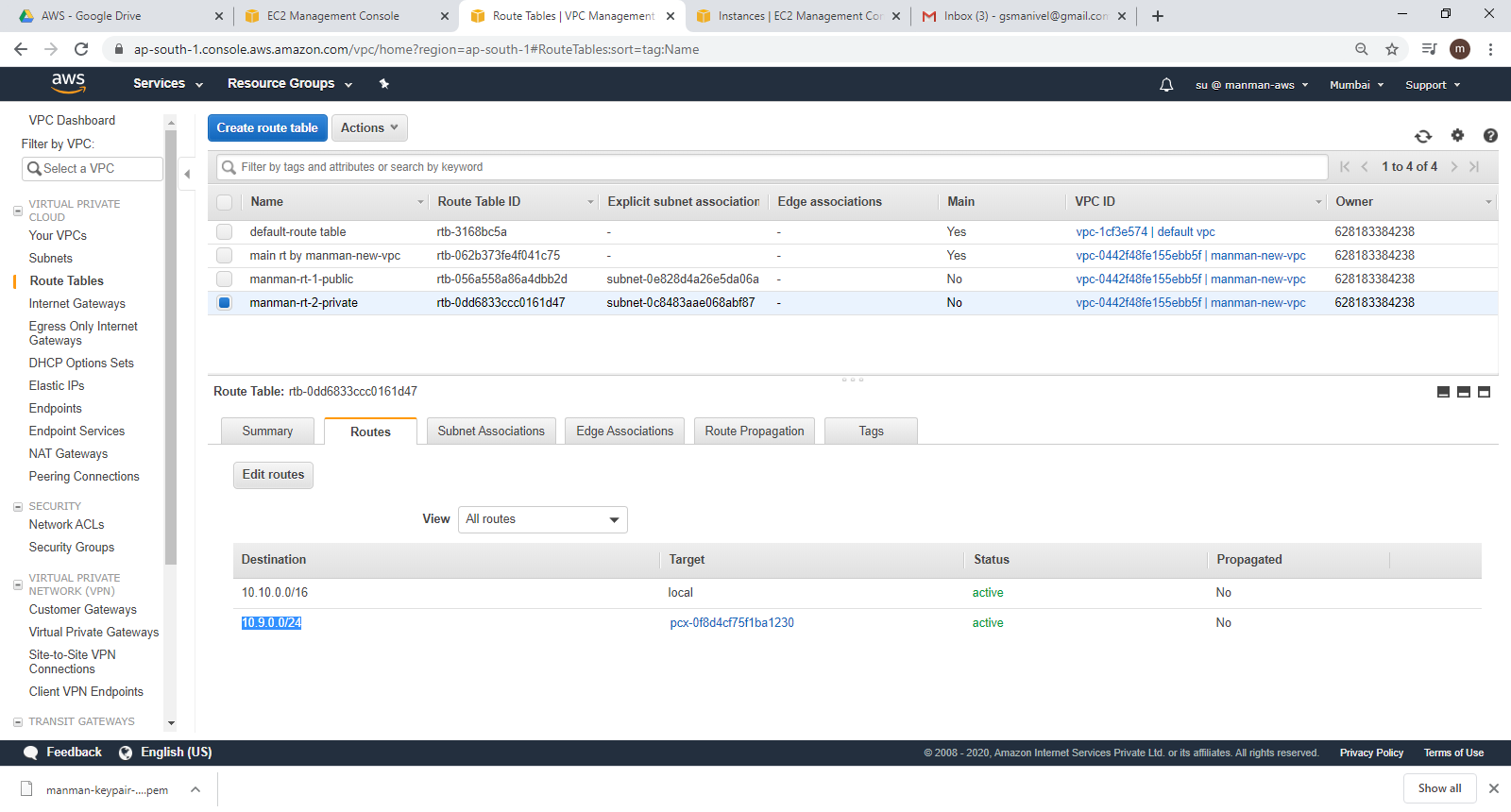

* N.Virginia Region:

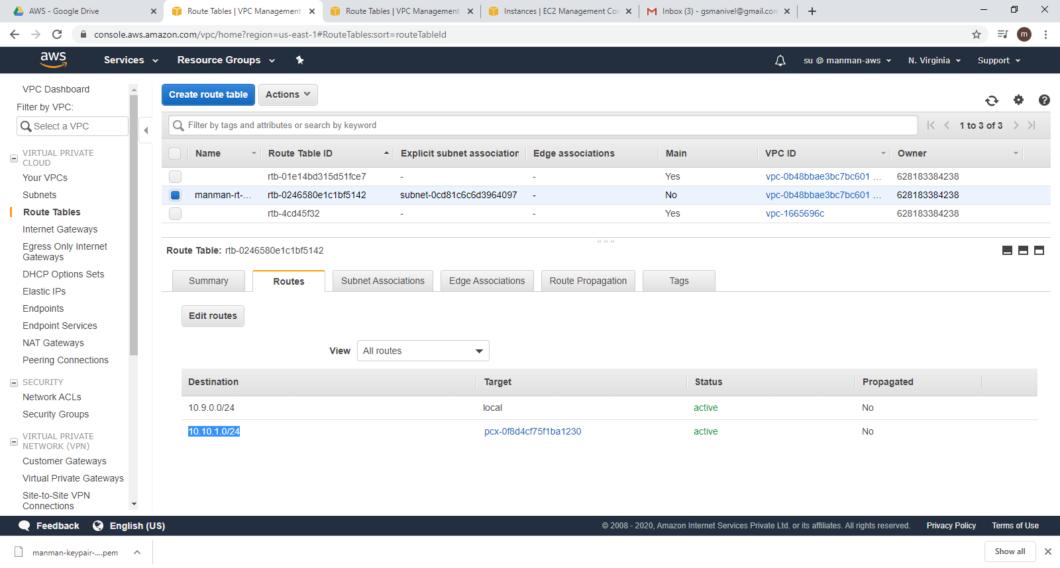

Now , ping to machine 3 from machine 2

